Ordinal Scale
# Source: AI Source: Provided by: [Data Path: Persons Table -> ID Column: 1, Name_En Column: Motasem Essam] -> From: [ChatGPT] on [7/17/2026]
The Ordinal Scale is the second level of measurement. It is used to classify data into categories that have a meaningful order or ranking, but the differences (intervals) between the categories are not necessarily equal or measurable.
Unlike the Nominal Scale, which only classifies data, the Ordinal Scale also indicates relative position (such as first, second, or third). However, it does not indicate how much greater or smaller one category is compared to another.

Definition
# Source: AI Source: Provided by: [Data Path: Persons Table -> ID Column: 1, Name_En Column: Motasem Essam] -> From: [ChatGPT] on [7/17/2026]
An Ordinal Scale is a measurement scale that classifies observations into ordered categories where the ranking is meaningful, but the intervals between successive categories are unknown or unequal.

Purpose
# Source: AI Source: Provided by: [Data Path: Persons Table -> ID Column: 1, Name_En Column: Motasem Essam] -> From: [ChatGPT] on [7/17/2026]
The ordinal scale is used to:
- Rank observations.
- Compare relative positions.
- Organize qualitative data with a natural order.
- Measure preferences, opinions, and performance levels.
- Support non-parametric statistical analysis.

Characteristics
# Source: AI Source: Provided by: [Data Path: Persons Table -> ID Column: 1, Name_En Column: Motasem Essam] -> From: [ChatGPT] on [7/17/2026]
An ordinal scale:
- Classifies observations into categories.
- Has a meaningful order.
- Indicates relative ranking.
- Does not have equal intervals.
- Does not have a true zero.
- Does not support meaningful arithmetic operations such as addition or subtraction.

Properties
# Source: AI Source: Provided by: [Data Path: Persons Table -> ID Column: 1, Name_En Column: Motasem Essam] -> From: [ChatGPT] on [7/17/2026]
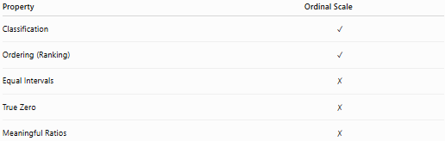
Property | Ordinal Scale
Classification | ✓
Ordering (Ranking) | ✓
Equal Intervals | ✗
True Zero | ✗
Meaningful Ratios | ✗

Examples
# Source: AI Source: Provided by: [Data Path: Persons Table -> ID Column: 1, Name_En Column: Motasem Essam] -> From: [ChatGPT] on [7/17/2026]
Educational Grades
Categories:
- Excellent
- Good
- Fair
- Poor
The order is meaningful:
Excellent > Good > Fair > Poor
However, the difference between Excellent and Good is not necessarily the same as the difference between Good and Fair.

Satisfaction Survey
Categories:
- Very Satisfied
- Satisfied
- Neutral
- Dissatisfied
- Very Dissatisfied
The responses are ranked, but the spacing between them is subjective.

Military Rank
Examples:
- General
- Colonel
- Major
- Captain
- Lieutenant
Each rank has a defined order.

Competition Results
- 1st Place
- 2nd Place
- 3rd Place
The ranking is known, but the performance gap is not.

Pain Level
Categories:
- No Pain
- Mild Pain
- Moderate Pain
- Severe Pain
These levels have an order but not equal measurable intervals.

Numerical Labels
# Source: AI Source: Provided by: [Data Path: Persons Table -> ID Column: 1, Name_En Column: Motasem Essam] -> From: [ChatGPT] on [7/17/2026]
Numbers may be assigned to ordinal categories.
Example:
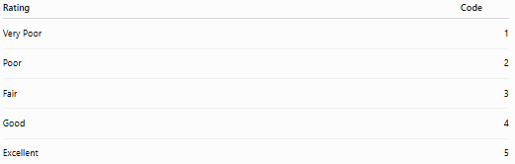
Rating | Code
Very Poor | 1
Poor | 2
Fair | 3
Good | 4
Excellent | 5
The numbers indicate rank, not equal numerical differences.
For example:
- 5 is higher than 4.
- But the improvement from 4 to 5 is not necessarily equal to the improvement from 2 to 3.

Mathematical Operations
# Source: AI Source: Provided by: [Data Path: Persons Table -> ID Column: 1, Name_En Column: Motasem Essam] -> From: [ChatGPT] on [7/17/2026]
Allowed
- Comparison
- Greater than / Less than
- Ranking
- Ordering
Example:
Good > Fair

Not Appropriate
- Addition
- Subtraction
- Multiplication
- Division
- Meaningful ratios
Example:
It is incorrect to say:
Excellent = twice Good

Statistical Measures
Common statistics for ordinal data include:
- Frequency
- Percentage
- Mode
- Median
- Percentiles
- Rank Correlation
The mean (average) is generally not appropriate because equal intervals are not guaranteed.

Applications
# Source: AI Source: Provided by: [Data Path: Persons Table -> ID Column: 1, Name_En Column: Motasem Essam] -> From: [ChatGPT] on [7/17/2026]
Ordinal scales are commonly used in:
- Surveys
- Questionnaires
- Psychology
- Education
- Medicine
- Market research
- Customer satisfaction studies
- Performance evaluations
- Risk assessments
- Social sciences

Advantages
# Source: AI Source: Provided by: [Data Path: Persons Table -> ID Column: 1, Name_En Column: Motasem Essam] -> From: [ChatGPT] on [7/17/2026]
The ordinal scale:
- Preserves ranking information.
- Is easy to understand.
- Supports comparison of relative positions.
- Works well for subjective assessments.
- Requires fewer assumptions than interval or ratio scales.

Limitations
# Source: AI Source: Provided by: [Data Path: Persons Table -> ID Column: 1, Name_En Column: Motasem Essam] -> From: [ChatGPT] on [7/17/2026]
The ordinal scale:
- Does not measure the size of differences.
- Cannot support meaningful arithmetic.
- Cannot determine exact distances between categories.
- Does not have a true zero.

Common Mistakes
# Source: AI Source: Provided by: [Data Path: Persons Table -> ID Column: 1, Name_En Column: Motasem Essam] -> From: [ChatGPT] on [7/17/2026]
- Assuming equal intervals between ranks.
- Calculating averages of ordinal ratings without justification.
- Treating ordinal data as ratio data.
- Assuming that category codes represent actual quantities.
Example:
Ratings:
1, 2, 3, 4, 5
These numbers represent order, not equal measurement units.

Ordinal Scale vs. Nominal Scale
# Source: AI Source: Provided by: [Data Path: Persons Table -> ID Column: 1, Name_En Column: Motasem Essam] -> From: [ChatGPT] on [7/17/2026]
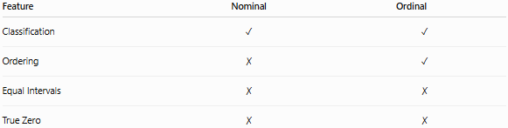
Feature | Nominal | Ordinal
Classification | ✓ | ✓
Ordering | ✗ | ✓
Equal Intervals | ✗ | ✗
True Zero | ✗ | ✗
Example:
Nominal:
- Red
- Blue
- Green
Ordinal:
- Low
- Medium
- High

Ordinal Scale vs. Interval Scale
# Source: AI Source: Provided by: [Data Path: Persons Table -> ID Column: 1, Name_En Column: Motasem Essam] -> From: [ChatGPT] on [7/17/2026]
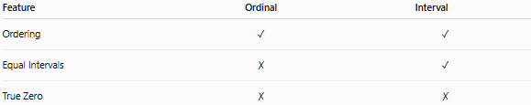
Feature | Ordinal | Interval
Ordering | ✓ | ✓
Equal Intervals | ✗ | ✓
True Zero | ✗ | ✗
Example:
Ordinal:
- Small
- Medium
- Large
Interval:
- Temperature in Celsius

Key Points
# Source: AI Source: Provided by: [Data Path: Persons Table -> ID Column: 1, Name_En Column: Motasem Essam] -> From: [ChatGPT] on [7/17/2026]
- The Ordinal Scale classifies data and provides a meaningful ranking.
- The order is meaningful, but the differences between categories are not measurable or equal.
- Arithmetic operations are generally not appropriate.
- Suitable statistical measures include:
  - Frequency
  - Percentage
  - Mode
  - Median
  - Percentiles
- It is widely used for rankings, ratings, preferences, and qualitative assessments.

Conclusion
# Source: AI Source: Provided by: [Data Path: Persons Table -> ID Column: 1, Name_En Column: Motasem Essam] -> From: [ChatGPT] on [7/17/2026]
The Ordinal Scale is a measurement scale that classifies observations into ordered categories, allowing meaningful comparisons of relative position while not providing information about the magnitude of differences between categories. It is especially useful for ranking, preference studies, satisfaction surveys, educational grading, and performance evaluation. Although it offers more information than the Nominal Scale, it lacks the equal intervals and true zero required for arithmetic operations, making it most suitable for ordering and comparative analysis rather than quantitative measurement.

